- INTRODUCTION
The rapid growth of digital data and increasing privacy concerns in storage highlight the urgent need for strong encryption methods that protect user information from unauthorized access, including by service providers. The majority of cloud solutions typically rely on server-side encryption, in which the keys are controlled by the providers. Data breaches, insider threats, and government-mandated disclosures are all possible with this configuration. By developing a genuine end-to-end encrypted file storage system, the Encrypted File Vault project directly addresses these problems. Using the Web Crypto API, encryption and decryption only take place within the user's browser, guaranteeing that files become ciphertext prior to uploading. In a true zero-knowledge system, the server only handles encrypted data and is unable to access plaintext or keys since only the user has the decryption key.
The system, which is based on the MERN stack (MongoDB, Express, React, and Node.js), blends cutting-edge web technologies with well-established cryptographic standards. It employs SHA-256 hashing to verify integrity during downloads and AES-256-GCM for authenticated encryption. A contemporary, responsive interface created with Material UI, simple drag-and-drop uploads, and real-time passphrase strength analysis with visual cues and feedback are some of the key features. The project demonstrates useful privacy-preserving techniques in web applications while making strong encryption accessible to regular users by emphasising both high-level security and user-friendliness. The current requirements for data control and resistance to digital surveillance are satisfied by this design. It demonstrates a useful approach to using privacy-protecting techniques in web applications and simplifies advanced encryption for non-technical users. This strategy satisfies the increasing demands of the digital age for data control and surveillance protection
  - Project Description
By employing true end-to-end encryption, the "Encrypted File Vault" project provides a safe, privacy-focused file storage solution that eliminates the dangers of conventional cloud services. This system manages all encryption and decryption directly in the user's browser via the Web Crypto API, in contrast to conventional platforms where service providers hold encryption keys and may access user data. Only ciphertext is sent to the server because files are encrypted using AES-256-GCM before being uploaded. The passphrase, also known as the decryption key, is never sent or stored; it only remains on the user's device. This establishes a total zero-knowledge configuration that protects against insider threats, breaches, and illegal access.
The platform has a modern, responsive interface driven by Material UI and is constructed with the MERN stack (MongoDB, Express.js, React.js, Node.js). Users can download files with automatic SHA-256 integrity verification to identify any tampering, upload files using drag-and-drop, and get real-time key strength feedback. Users are prompted to safely store their key after a successful upload by a strong warning. The Encrypted File Vault enables people and organisations to securely store sensitive files in the cloud while retaining complete control over their data by fusing military-grade security with an intuitive design.

2.LITERATURE SURVEY
2.1 Existing and Proposed System
Current cloud storage systems such as Google Drive, Dropbox, OneDrive, and similar platforms predominantly rely on server-side encryption, where the service provider generates and manages the encryption keys. This model, while convenient, poses significant privacy risks as the provider can potentially access plaintext data. In the event of data breaches, insider threats, or legal requests, user files remain vulnerable. Although some services offer optional client-side encryption through third-party tools (e.g., Cryptomator or Boxcryptor), these require additional setup and lack seamless integration, reducing usability. Research highlights that most widely adopted solutions do not provide true end-to-end encryption by default, resulting in limited user control and ongoing privacy concerns [1, 2, 3, 4].
The proposed Encrypted File Vault overcomes these shortcomings by implementing a true end-to-end encrypted file storage system using purely client-side cryptography. Built on the MERN stack, the application performs AES-256-GCM encryption, PBKDF2 key derivation and SHA-256 integrity verification entirely in the user's browser via the native Web Crypto API. This zero-knowledge design ensures that only encrypted data and metadata reach the server, with decryption keys never leaving the client device. Features such as real-time passphrase strength validation with visual feedback, intuitive drag-and-drop upload, and secure file management further enhance usability without compromising security. The system offers superior privacy, transparency, and control compared to existing solutions, demonstrating that military-grade protection can be achieved in a user-friendly web application [5, 6, 7, 8].
2.2 Feasibility study
2.2.1 Technical Feasibility Study
- The project is technically feasible with the widely used MERN stack, which includes MongoDB, Express.js, React.js, and Node.js.
- Client-side encryption and decryption use the native Web Crypto API. This feature is standard in all modern browsers and offers reliable support for AES-256-GCM and PBKDF2.
- The SHA-256 hashing for integrity checks is efficiently managed through the same Web Crypto API, without needing any external tools.
- Libraries like Material UI, Axios, Framer Motion, bcrypt, and JWT are well-documented and supported by active communities.
- The system only needs standard development machines that have Node.js and a modern browser; no special hardware is required.
- Integration between the frontend, backend, and database works smoothly using REST APIs and established Node.js libraries.
2.2.2 Operational Feasibility Study
- Users without technical knowledge can easily operate the system without any training. Its user interface is straightforward and intuitive, featuring drag-and-drop file upload, clear instructions, and visible feedback.
- With a modern web browser and an internet connection, all essential functions upload, encryption, download, and decryption—work smoothly in the browser.
- User authentication is easy, using standard registration and login forms.
- The post-upload key warning dialogue helps reduce mistakes related to key loss.
- It ensures that users understand the importance of keeping their passphrase safe.
- The responsive design powered by Material UI works well across different user environments, including PCs, tablets, and mobile devices.
- The system uses standard MERN stack technologies, so it requires minimal maintenance. Anyone familiar with JavaScript ecosystems can handle updates and fix issues.
2.2.3 Economic Feasibility Study
- The project has no licensing or software costs because it uses only free and open-source technologies (MERN stack, Web Crypto API, Material UI).
- No expensive hardware or specialised tools are needed for development; all you need is a regular computer and an internet connection.
- With minimal hosting costs, deployment can be carried out on free or inexpensive cloud platforms.
- Because the system utilizes widely used JavaScript technology, with numerous community resources available, maintenance expenses are minimal.
Since the browser handles all cryptographic operations natively, there are no ongoing costs for third-party encryption providers. When compared to professional encrypted storage systems, the solution is quite affordable, making it appropriate for small-scale organisational, academic, or personal use.
- The project has no licensing or software costs because it uses only free and open-source technologies (MERN stack, Web Crypto API, Material UI).

  - Tools and Technologies used
2.3.1 Programming Languages
- JavaScript
JavaScript is used as the primary programming language for both frontend and backend development. It is used to implement application logic, API handling, and interaction with AI services.
- TypeScript
TypeScript is used to improve code quality and reliability by providing type safety in the frontend components.

2.3.2 Frontend Technologies
- Next.js(ReactFramework)
Used as the main frontend framework with App Router for building the web application.
- React18
Used to develop reusable user interface components for login and user dashboard.
- TailwindCSS
Used for designing a responsive and clean user interface.
- MaterialUI(MUI)
Provides a modern, responsive component library (e.g., buttons, dialogs, cards, progress bars) for a clean and professional user interface.
- Framer Motion
Used for smooth animations and transitions throughout the application.

2.3.3 Backend and Database Technologies
- Node.js
The runtime environment for the backend server, handling API routes and business logic.
- Express.js
The web framework used to build RESTful APIs for user authentication, file upload, and download.
- MongoDB
The NoSQL database used to store user information and encrypted file metadata.

2.3.4 Security & Encryption Technologies
- Web Crypto API
Built-in browser API used for client-side AES-256-GCM encryption, PBKDF2 key derivation, and SHA-256 hashing.
- Bcrypt
Used for secure password hashing during user registration.
- JWT (JSON Web Tokens)
Used for secure user authentication and protected routes.

2.3.5 Supporting Libraries and Tools
- Axios
Used for making HTTP requests between frontend and backend services.
- Multer
Middleware for handling file uploads on the backend.
- Nodemon
Development tool for auto-restarting the server during development.
- ESLint & Prettier
Used for code linting and formatting to maintain clean and consistent code quality.
  - Software and Hardware Requirements

Table 2.1 : Hardware Requirements
Component | Specification
Processor | Intel Core i5 or higher
RAM | Minimum 8 GB
Storage | Minimum 20 GB free disk space
Internet Connection | Stable broadband
System Type | Laptop or Desktop computer

Table 2.2: Software Requirements
Component | Specification
Operating System | Windows 10 or above / macOS / Linux
Programming Environment | Node.js (version 18 or above)
Frontend Framework | React.js with Material UI
Backend Framework | Node.js with Express.js
Database | MongoDB (local or MongoDB Atlas)
Development Tools | Visual Studio Code, npm
Web Browser | Google Chrome / Microsoft Edge (latest version)

3. SOFTWARE REQUIREMENTS SPECIFICATION
3.1 Users
- End Users: People or institutions that must safely store private documents (main users who upload, manage, and download encrypted files).
- Administrators: System maintainers who keep monitoring on the database and server health (if it's in production).

3.1.1 Scope and Objective
The Encrypted File Vault is a web-based solution that provides true end-to-end encrypted storage for files. It enables users to encrypt and decrypt files on their end using passphrases they create. The service allows for secure uploads, listings, and downloads, and includes integrity checks. The system verifies passphrase strength in real time during uploads and adopts a zero-knowledge approach. This means the server cannot access plaintext information or decryption keys. Its responsive, user-friendly design ensures compatibility with both desktop and mobile browsers, making advanced encryption accessible to everyone.
Provide military-grade security via AES-256-GCM encryption in a browser. Data should not get exposed, even if the server is compromised. The integrity of the file is checked using SHA-256.To ensure strong passphrase practices through real-time feedback. To facilitate secure file sharing and storage beyond technical users. To show practical application of privacy-preserving web technologies.
3.1.2 Assumptions and Dependencies
- Users have access to a modern web browser that supports the Web Crypto API, including the latest versions of Chrome, Firefox, and Edge.
- Users keep and securely store their own decryption passphrase.
- A stable internet connection is necessary for upload and downloads operations.
- Users know that losing passphrases leads to permanent data inaccessibility.
- Reliance on browser compatibility for the Web Crypto API affects encryption tasks.
- System efficiency depends on the client device's ability to encrypt large files.
- The backend relies on the availability of the Node.js runtime and MongoDB.
- Secure functioning requires proper setup of HTTPS and authentication services.

3.2 Functional Requirements
The system shall:
- Enable users to securely create accounts and log in with their email and password.
- Allow users to upload files with client-side encryption, utilizing a passphrase provided by them.
- Conduct real-time validation of passphrase strength and offer visual feedback. Calculate and store the SHA-256 hash of the original file to ensure integrity verification.
- Show a list of uploaded encrypted files along with metadata (file name, size, upload date).
- Permit users to download encrypted files and decrypt them on the client-side using the correct passphrase.
- Check file integrity against the stored SHA-256 hash during the download process.
- Provide clear error messages when the passphrase is incorrect or if there is an integrity failure.
- Encourage users to save their passphrase right after a successful upload. Secure all routes that require user authentication.
3.3 Non-Functional Requirements
- Performance: The encryption and decryption processes for reasonably sized files should be efficient and use browser resources.
- Scalability: The system must support multiple users at the same time with cloud-based deployment.
- Security: Use a zero-knowledge design; employ HTTPS, bcrypt for password storage, and JWT for managing sessions.
- Reliability: Ensure consistent encryption and decryption along with integrity checks across all supported browsers.
- Usability: Provide a user-friendly, responsive interface with clear guidance and feedback.
- Availability: The application must be accessible 24/7 and have minimal downtime when hosted on reliable platforms.
- Maintainability: The code should follow a clean structure for easy updates and bug fixes.
- Portability: The web application should work smoothly on modern desktop and mobile browsers.

4. SYSTEM DESIGN
4.1 System Architecture

The system is built on a client-server model. This model separates the tasks between the client (browser) and the server. It focuses on client-side processing to improve security while using server-side components for jobs like authentication and data storage. This setup ensures scalability, makes maintenance easier, and provides real zero-knowledge encryption.
I. User Layer
- It includes end users who upload, manage, and download encrypted files.
- Users access the system through a modern web browser.
- An admin role is not needed for regular operations; server monitoring can happen externally.
II. Presentation Layer
- Developed with React.js, using Material UI and Framer Motion.
Features responsive user interfaces for login and registration, a drag-and-drop upload page, a key strength meter, a file list dashboard, and a download or decryption interface.
- Manages encryption, decryption, key derivation, and integrity checks on the client side with the Web Crypto API.
III.Application Layer (Backend)
- Developed with Node.js and Express.js.
- Manages user authentication (JWT), secured routes, and file metadata storage.
- Provides encrypted file blobs and handles upload/download requests without accessing plaintext.
IV. Security and Cryptography Layer
- The entire encryption and decryption process occur in the browser using the Web Crypto API (AES-256-GCM, PBKDF2, SHA-256).
- This ensures zero-knowledge, which means the server cannot access the keys or any plaintext information.

V. Data Management Layer
- Uses MongoDB, either locally or through MongoDB Atlas, as a NoSQL database.
- Stores user credentials in hashed form, session tokens, and encrypted file information, including filename, size, upload date, and SHA-256 hash.

VI. Deployment and Infrastructure Layer
- The application is deployed on cloud platforms such as Vercel or Emergent.sh.
- The frontend can be deployed on platforms like Vercel or Netlify.
- The backend can be hosted on Render, Heroku, or other Node hosting services.
- It allows HTTPS for secure communication and offers simple scalability with cloud service providers.
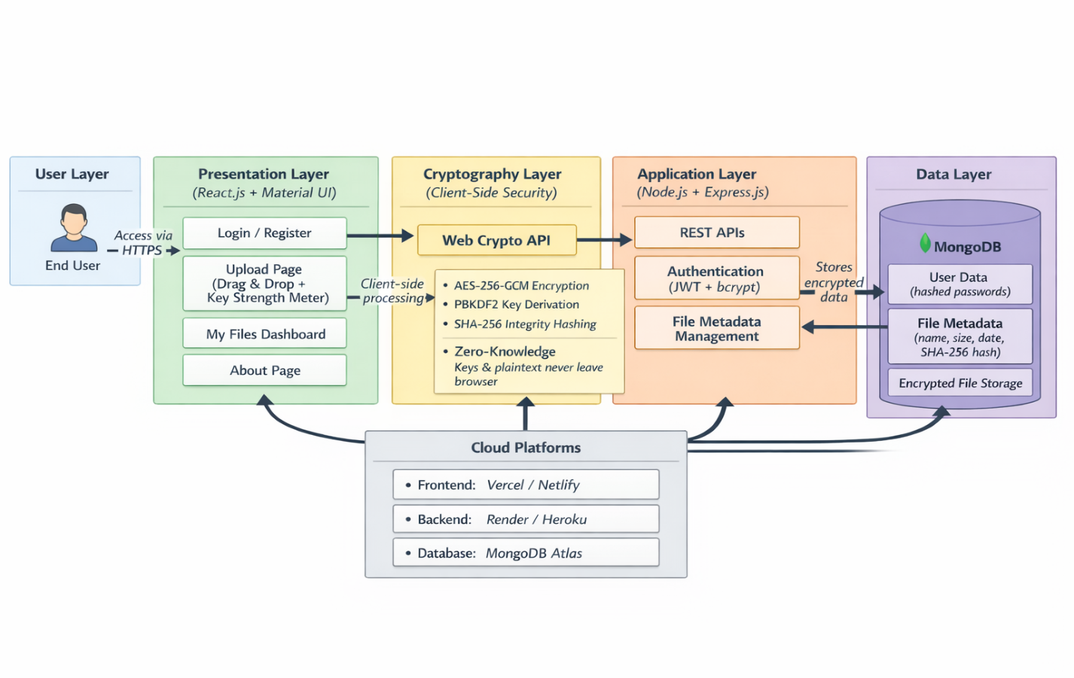
Fig. 4.1: System Architecture Diagram
4.2 System Perspective
The Encrypted File Vault is an online tool that provides secure, end-to-end encrypted file storage, focusing on user privacy and data control. It works as a standalone platform accessible through any modern web browser, so no software downloads or plugins are necessary. Users can sign up, upload files that are encrypted on their devices, view their list of encrypted files, and download or decrypt files using their passphrase.
From a system viewpoint, the application acts as a secure link between the client browser and the server. It handles all cryptographic functions, including AES-256-GCM encryption, key derivation, and SHA-256 hashing, entirely within the browser through the Web Crypto API. This approach ensures a true zero-knowledge model; the server only receives and keeps encrypted data along with some metadata. The backend, built on Node.js and Express, manages authentication and file handling. MongoDB stores user credentials and metadata. By deploying on cloud platforms, the system offers scalability, reliability, and accessibility. This setup is ideal for individuals and organizations seeking private, tamper-proof file storage without depending on third-party providers that might handle sensitive information.
4.3 Context Diagram
- End User: Signs up, logs into the system, uploads document, reviews the list of files, and downloads or decrypts them.
- Web Browser: The interface through which the user interacts with the application, supporting client-side encryption and decryption processes.
- Web Crypto API: A built-in browser service used for AES-256-GCM encryption, PBKDF2 key generation, and SHA-256 hashing.
- Backend Server (Node.js + Express.js): Manages user authentication, stores encrypted file data, and handles file metadata.
- Database (MongoDB): Stores user credentials (in hashed form), JWT tokens, and file metadata (including filename, size, upload date, and SHA-256 hash).
- Cloud Hosting Platform: Offers hosting for the frontend, backend, and database services, ensuring deployment and accessibility.

The figure 4.2 depicts context diagram with different modules interaction. The user interacts with the system using a web browser to register or log in, upload files (secured by a passphrase), and download or decrypt files. The browser uses the Web Crypto API to manage all encryption, decryption, key derivation, and integrity hashing on the client side. Encrypted files and their metadata are sent to the backend server, which stores them without accessing the plaintext data. The backend server works with MongoDB for user authentication and for storing and retrieving file metadata. The entire application is hosted and managed on cloud platforms to ensure scalability, reliability, and constant availability.
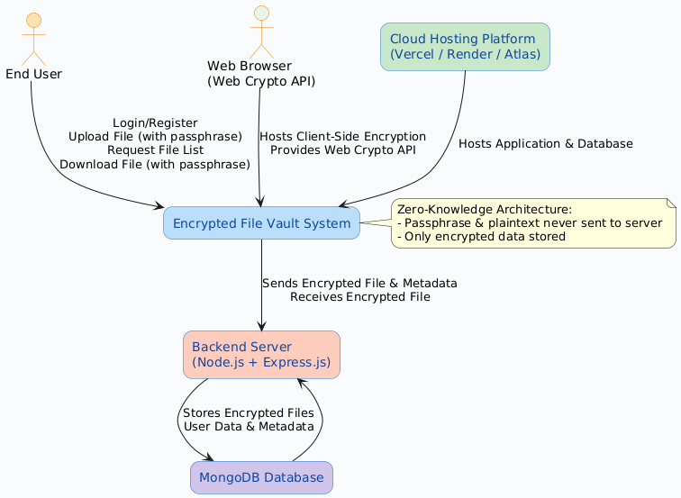
Fig.4.2: Context diagram of encrypt vault

5. DETAILED DESIGN
5.1 Data Flow Diagram (DFD)
The Data Flow Diagram shows how data moves through the Encrypted File Vault system. Figure 5.1 illustrates how user inputs are processed for encryption, storage, and retrieval and the diagram focuses on client-side security. Initially the user submits their credentials for authentication, and the system verifies them. To upload, the user selects a file and enters a passphrase.
- The system performs client-side encryption and calculates a hash. The encrypted file, along with metadata that includes the hash, is sent to the server for storage.
- The server saves the encrypted information and confirms success to the user. For downloading, the user requests a file, and the system retrieves the encrypted data from storage.
- It performs client-side decryption and integrity validation using the user’s passphrase and the stored hash.
- The resulting data, which can be either the decrypted file or error messages, is delivered to the user. This shows how data moves from user entry to encryption, storage, and decryption. To highlight secure data management with an emphasis on client-side activities. To explain the logical order of information without focusing on technical execution details.
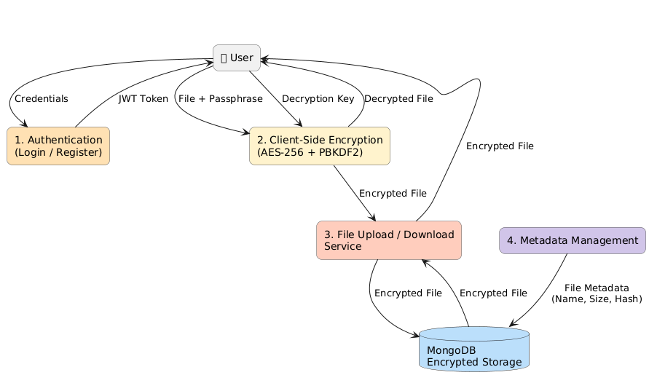

Fig.5.1: Data flow diagram of encrypt vault
5.2 Activity Diagram
The activity diagram demonstrated in Figure 5.2 shows the steps involved in uploading and downloading files in the Encrypted File Vault. It explains how the user, browser, and server interact from the time a file is selected until it is securely retrieved. The procedure starts when the user logs into the platform. To upload a file, the user selects a file and enters a passphrase. The system checks the passphrase's strength and gives feedback. The file is encrypted on the client side using AES-256-GCM and hashed with SHA-256. The encrypted file and its metadata are sent to the server. A key warning dialog appears to remind the user to save the passphrase. To download a file, the user picks it and types in the passphrase. The server retrieves the encrypted file. The system performs client-side decryption and an integrity check. The user gets a message that either confirms success or reports an error, such as an incorrect key or detected tampering.
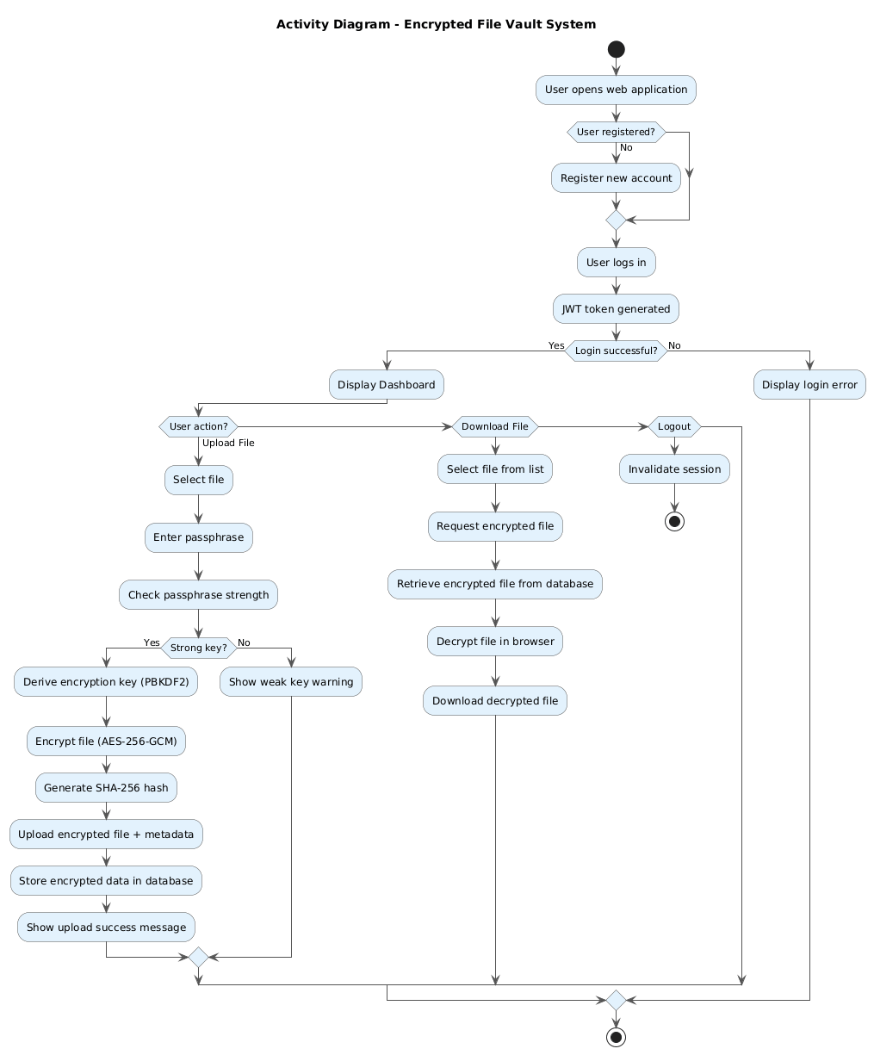

Fig.5.2: Activity diagram of encrypt vault

5.3 Use Case Diagram
The use case diagram Figure 5.3 shows how users interact with the Encrypted File Vault system. It highlights the main features available to end users during the secure processes of uploading, storing, and retrieving files.
The user either registers or logs into the system using their credentials. The user selects a file and enters a passphrase for encryption. The system checks the passphrase's strength and provides immediate feedback. The system performs client-side encryption and calculates the SHA-256 hash. The encrypted file, along with its metadata, is uploaded to the server. The user can see a list of stored encrypted files. The user chooses a file to download and enters the passphrase. The system retrieves the encrypted file and performs client-side decryption. The system checks the file's integrity using the saved hash. The decrypted file is shown to the user, or an error message appears if the key is incorrect or has been changed.
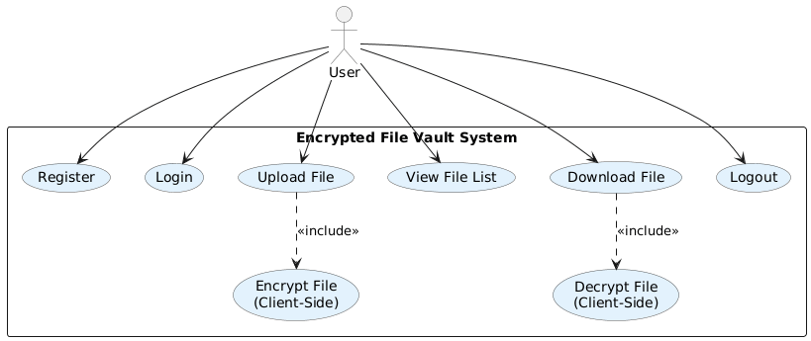
Fig.5.3: Use case diagram of encrypt vault

5.4 Sequence Diagram
The sequence diagram Figure 5.4 shows the order of interactions between the user, browser, system components, and server during file encryption and decryption. It illustrates how requests and responses flow steadily from the file upload stage to the secure download.
The user accesses the system and chooses a file to upload. The user enters a passphrase, and the browser checks its strength with the key analyser. The browser creates a key and encrypts the file using the Web Crypto API (AES-256-GCM). The browser calculates the SHA-256 hash of the original file. The encrypted file, along with metadata that includes the hash, is sent to the backend server. The backend saves the encrypted information in MongoDB and confirms that the operation was successful. To download, the user requests a file and provides the passphrase. The backend retrieves the encrypted file and metadata from MongoDB. The browser decrypts the file using the Web Crypto API and checks its integrity with the SHA-256 hash.The decrypted file is given to the user, or an error message appears if the key is incorrect or has been modified.

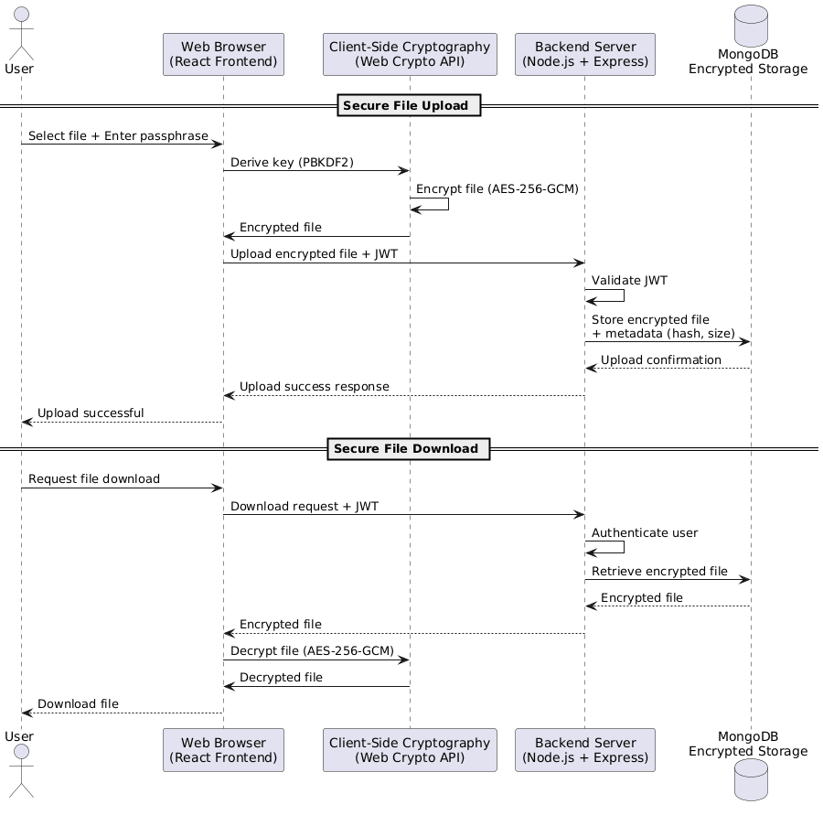
Fig.5.4: Sequence diagram of encrypt vault

6. IMPLEMENTATION
6.1 Snippet Code
Snippet 1: App.jsx – Main application routing and layout
Purpose:
Defines the main application routing and layout, managing navigation and protected routes for authenticated users.
import { BrowserRouter as Router, Routes, Route } from "react-router-dom";
import Login from "./pages/Login";
import Register from "./pages/Register";
import Dashboard from "./pages/Dashboard";
import Upload from "./pages/Upload";
import MyFiles from "./pages/MyFiles";
import AIAdvisor from "./pages/AIAdvisor";
import About from "./pages/about";
import Contact from "./pages/contactus";
import Feedback from "./pages/feedback";
import ForgotPassword from "./pages/ForgotPassword";
import Navbar from "./components/Navbar";
import GlobalAIChatbot from "./components/GlobalAIChatbot";

const App = () => {
return (
<Router>
<Navbar />
<Routes>
<Route path="/" element={<Login />} />
<Route path="/register" element={<Register />} />
<Route path="/dashboard" element={<Dashboard />} />
<Route path="/upload" element={<Upload />} />
<Route path="/myfiles" element={<MyFiles />} />
<Route path="/ai-advisor" element={<AIAdvisor />} />
<Route path="/about" element={<About />} />
<Route path="/contact" element={<Contact />} />
<Route path="/feedback" element={<Feedback />} />
<Route path="/forgot-password" element={<ForgotPassword />} />
</Routes>
{/* Global AI Chatbot - Available on all pages */}
<GlobalAIChatbot />
</Router>
);
};

export default App;

Snippet 2: Login.jsx – User login component
Purpose:
Handles secure user login with email/password validation and JWT token storage.
import React, { useState } from "react";
import {
Box,
Typography,
TextField,
Button,
Paper,
IconButton,
InputAdornment,
Alert,
} from "@mui/material";
import { Visibility, VisibilityOff, LockOutlined } from "@mui/icons-material";
import { motion } from "framer-motion";
import { Link, useNavigate } from "react-router-dom";
import { login } from "../services/authService";

const Login = () => {
const [showPassword, setShowPassword] = useState(false);
const [formData, setFormData] = useState({ email: "", password: "" });
const [error, setError] = useState("");
const [loading, setLoading] = useState(false);
const navigate = useNavigate();

const handleChange = (e) =>
setFormData({ ...formData, [e.target.name]: e.target.value });

const handleSubmit = async (e) => {
e.preventDefault();
setError("");
setLoading(true);

try {
await login(formData.email, formData.password);
navigate("/dashboard");
} catch (err) {
setError(err.response?.data?.message || "Login failed. Please try again.");
} finally {
setLoading(false);
}
};

return (
<Box
sx={{
height: "100vh",
display: "flex",
justifyContent: "center",
alignItems: "center",
background:
"linear-gradient(120deg, #1e3a8a, #2563eb, #9333ea, #0f172a)",
backgroundSize: "300% 300%",
animation: "gradientShift 12s ease infinite",
"@keyframes gradientShift": {
"0%": { backgroundPosition: "0% 50%" },
"50%": { backgroundPosition: "100% 50%" },
"100%": { backgroundPosition: "0% 50%" },
},
}}
>
<Box
sx={{
display: "flex",
flexDirection: { xs: "column", md: "row" },
width: "90%",
maxWidth: "1100px",
height: { xs: "auto", md: "80vh" },
borderRadius: "20px",
overflow: "hidden",
boxShadow: "0 0 40px rgba(0,0,0,0.3)",
backgroundColor: "#fff",
}}
>
{/* LEFT PANEL */}
<Box
sx={{
flex: 1,
background: "linear-gradient(135deg, #2563eb, #1e3a8a)",
color: "white",
display: "flex",
flexDirection: "column",
justifyContent: "center",
alignItems: "center",
padding: "40px",
textAlign: "center",
}}
>
<LockOutlined sx={{ fontSize: 70, mb: 2, color: "#93c5fd" }} />
<Typography variant="h4" sx={{ fontWeight: "bold", mb: 1 }}>
Encrypted File Vault
</Typography>
<Typography
variant="body1"
sx={{
opacity: 0.9,
maxWidth: "80%",
color: "#e2e8f0",
}}
>
Secure your data with AES encryption, hashing, and AI-powered protection.
</Typography>
</Box>

{/* RIGHT PANEL */}
<Box
sx={{
flex: 1,
display: "flex",
justifyContent: "center",
alignItems: "center",
backgroundColor: "#f9fafb",
py: { xs: 6, md: 0 },
}}
>
<motion.div
initial={{ opacity: 0, y: 30 }}
animate={{ opacity: 1, y: 0 }}
transition={{ duration: 1 }}
>
<Paper
elevation={8}
sx={{
p: 5,
width: "360px",
borderRadius: "16px",
textAlign: "center",
backgroundColor: "#ffffff",
}}
>
<Typography
variant="h5"
sx={{
fontWeight: "bold",
mb: 1,
color: "#111827",
}}
>
Welcome Back 🔐
</Typography>
<Typography variant="body2" sx={{ mb: 3, color: "#6b7280" }}>
Log in to access your encrypted vault.
</Typography>

{error && (
<Alert severity="error" sx={{ mb: 2 }}>
{error}
</Alert>
)}

<form onSubmit={handleSubmit}>
<TextField
fullWidth
margin="normal"
label="Email"
name="email"
type="email"
value={formData.email}
onChange={handleChange}
variant="outlined"
required
/>
<TextField
fullWidth
margin="normal"
label="Password"
name="password"
type={showPassword ? "text" : "password"}
value={formData.password}
onChange={handleChange}
variant="outlined"
required
InputProps={{
endAdornment: (
<InputAdornment position="end">
<IconButton
onClick={() => setShowPassword(!showPassword)}
edge="end"
>
{showPassword ? <VisibilityOff /> : <Visibility />}
</IconButton>
</InputAdornment>
),
}}
/>

{/* Forgot Password */}
<Typography
variant="body2"
sx={{
textAlign: "right",
color: "#2563eb",
mt: 1,
mb: 2,
cursor: "pointer",
fontWeight: "bold",
"&:hover": { textDecoration: "underline" },
}}
onClick={() => navigate("/forgot-password")}
>
Forgot Password?
</Typography>

<motion.div whileHover={{ scale: 1.03 }} whileTap={{ scale: 0.97 }}>
<Button
type="submit"
fullWidth
variant="contained"
disabled={loading}
sx={{
mt: 1,
py: 1.3,
fontSize: "1rem",
borderRadius: "30px",
background: "linear-gradient(90deg, #2563eb, #9333ea)",
boxShadow:
"0 4px 20px rgba(37,99,235,0.3), 0 0 20px rgba(147,51,234,0.3)",
"&:hover": {
background:
"linear-gradient(90deg, #1d4ed8, #7e22ce)",
},
}}
>
{loading ? "LOGGING IN..." : "LOGIN"}
</Button>
</motion.div>
</form>

{/* Register Link */}
<Typography sx={{ mt: 3, color: "#6b7280" }}>
Don’t have an account?{" "}
<Link
to="/register"
style={{
color: "#2563eb",
textDecoration: "none",
fontWeight: "bold",
}}
>
Register
</Link>
</Typography>
</Paper>
</motion.div>
</Box>
</Box>
</Box>
);
};

export default Login;

6.2 Screenshots

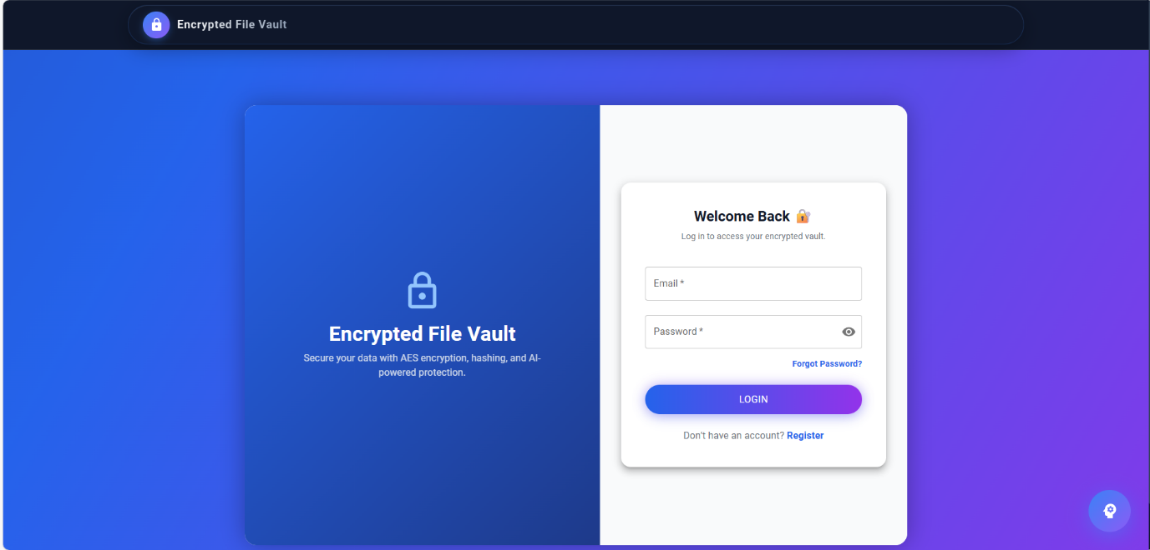Fig.6.1: Login page of encrypted file vault
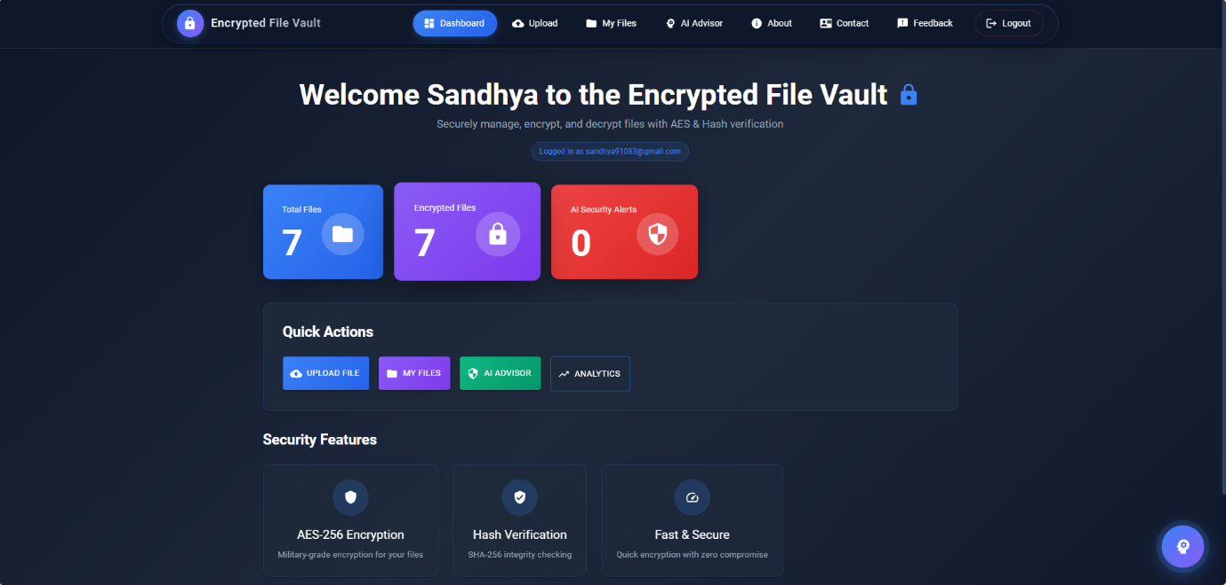
Fig.6.2: Dashboard of the encrypted file vault

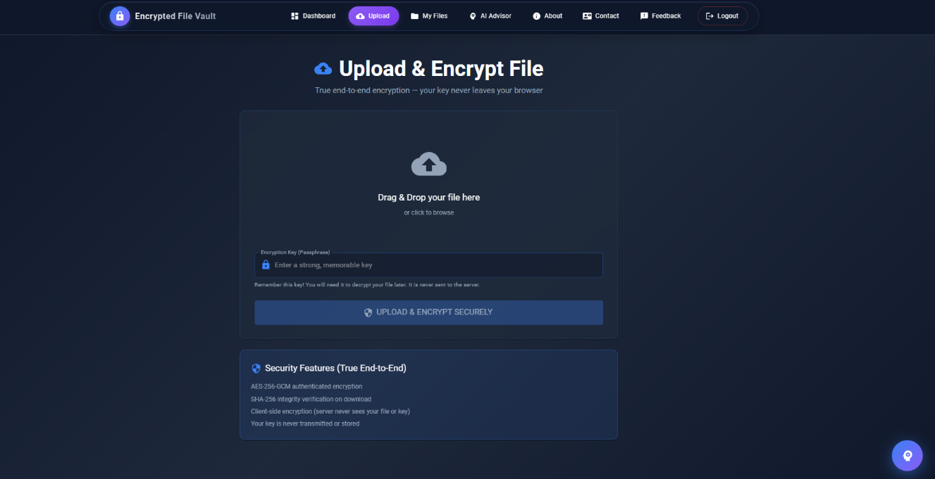Fig.6.3: Uploading the File
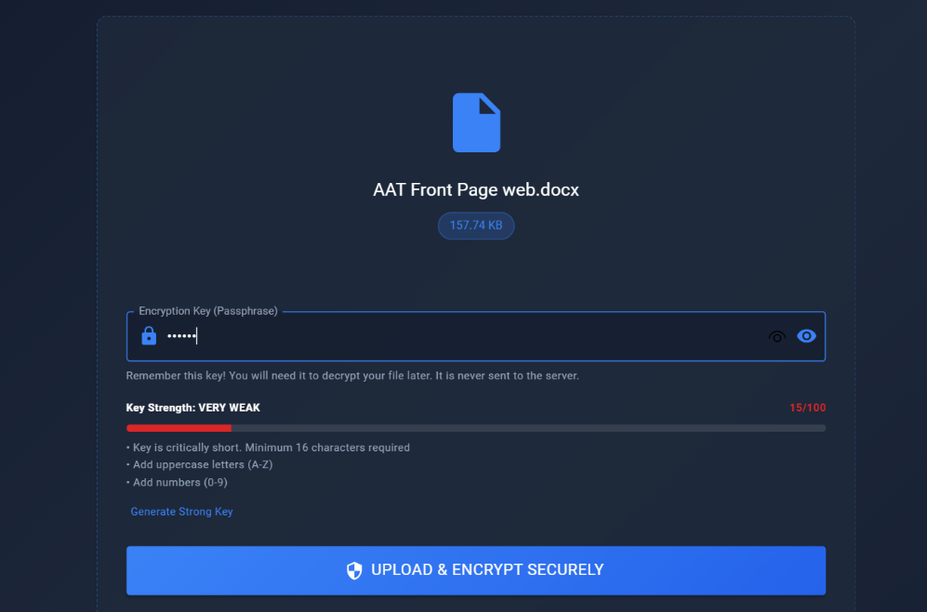
Fig.6.4: Key strength validation

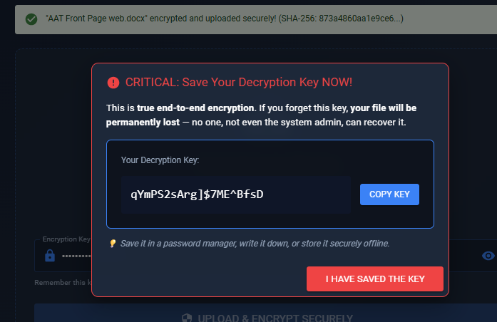Fig.6.5: Alert Notification
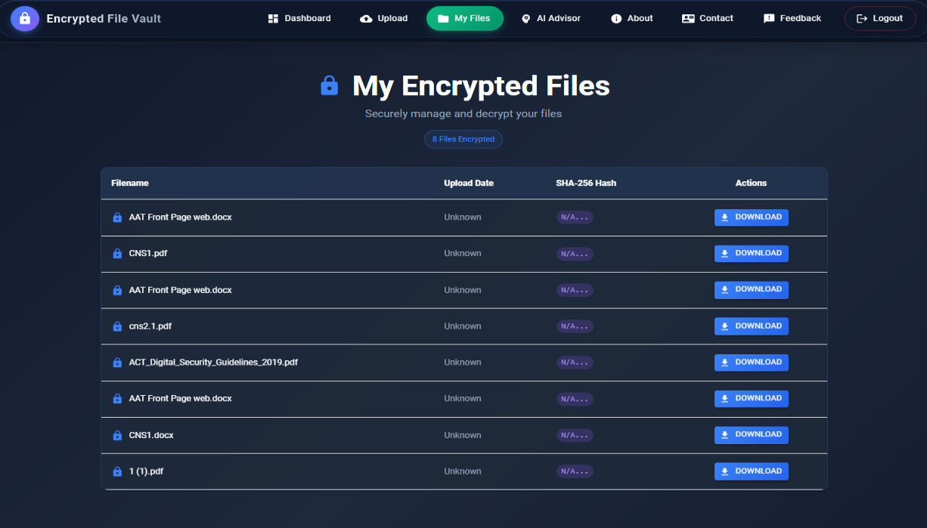
Fig.6.6: List of uploaded files under my files module

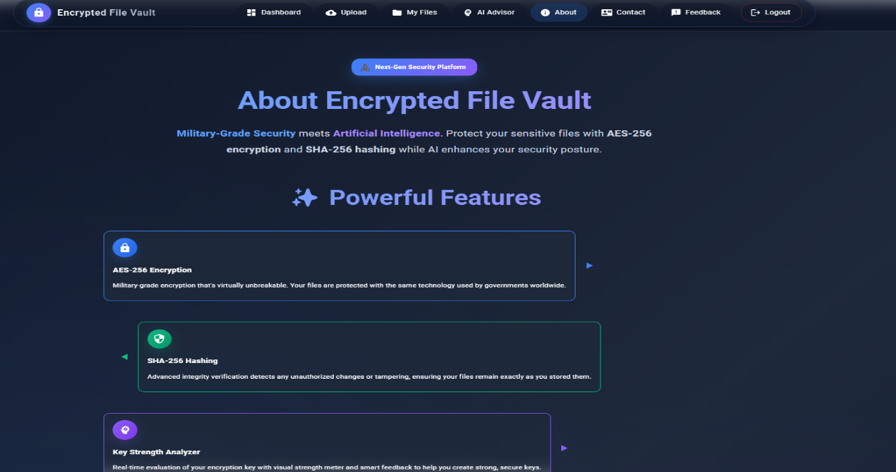Fig.6.7: About Us Page
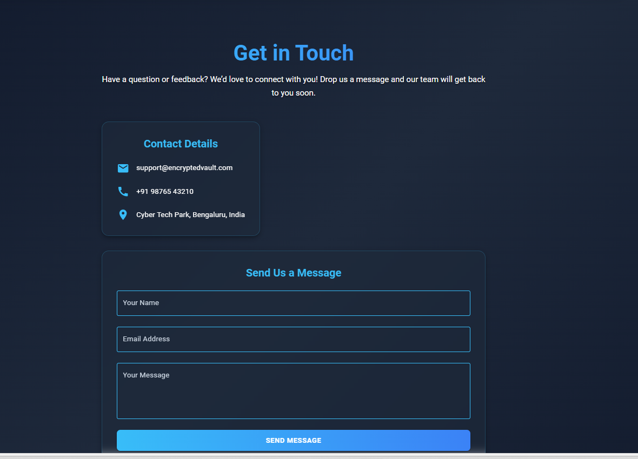
Fig.6.8:Contact Us Page

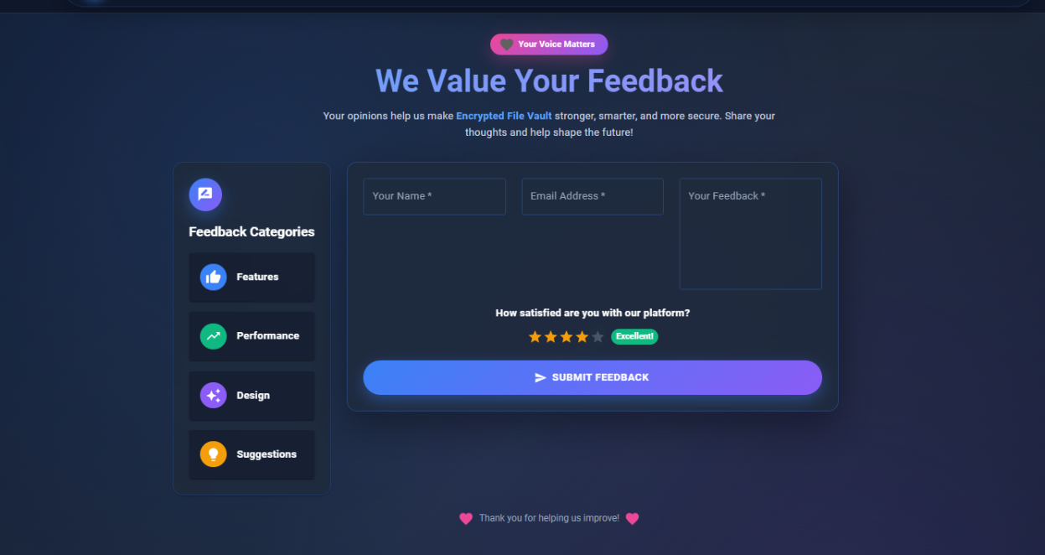Fig.6.9: Feedback Page

7. SOFTWARE TESTING

Software testing is crucial in developing the Encrypted File Vault. It ensures that the system works correctly, securely, and meets all required standards. The testing focused on verifying client-side encryption, server-side functionalities, user authentication, and overall user workflows. A variety of testing methods, including unit testing, integration testing, and manual test cases, were used to evaluate reliability, security, and performance.
7.1 Unit Testing
Unit testing focuses on testing individual modules of the application independently to ensure they function as expected. Each core component of the system was tested separately before integrating it with other modules.
The following units were tested.
- Client-side encryption component to ensure the proper functioning of AES-256-GCM encryption and key derivation using the Web Crypto API.
- SHA-256 hashing component to ensure the correct hash calculation for integrity verification.
- Key strength assessment module to check the accuracy of real-time scoring and feedback.
- Authentication service to confirm JWT token processing and manage secure routes.
- File upload and download handlers to verify the proper storage of metadata and manage encrypted files.
Unit testing helped identify logical errors early and ensured that each module performed its intended task correctly.

7.2 Test Cases
Table 7.1: Test Cases
Test Case ID | Test Description | Input | Expected Output | Status
TC01 | User registration | Valid email and password | User account created successfully | Pass
TC02 | User login | Valid credentials | Successful login and redirect to dashboard | Pass
TC03 | Invalid login | Wrong password | Error message displayed | Pass
TC04 | File upload with strong key | File + strong passphrase | File encrypted and uploaded successfully | Pass
TC05 | File upload with weak key | File + weak passphrase | Upload allowed with strength warning | Pass
TC06 | Download with correct key | Encrypted file + correct key | File decrypted and integrity verified | Pass
TC07 | Download with wrong key | Encrypted file + wrong key | "Wrong decryption key" error shown | Pass
TC08 | Integrity check failure | Tampered encrypted file | "Integrity check failed" error | Pass
TC09 | Access protected route without login | Direct access to /upload | Redirected to login page | Pass
TC10 | Large file handling | File > 50MB | Encryption completes in reasonable time | Pass

8. CONCLUSION
The Encrypted File Vault initiative clearly shows how end-to-end encryption works in a web application by using modern browser features. It uses the Web Crypto API for client-side AES-256-GCM encryption and SHA-256 hashing. The system ensures that files are encrypted before uploading, with only the user holding the decryption key. This zero-knowledge model blocks server-side access to unencrypted data, providing strong protection against breaches, insider threats, and unauthorized disclosures. Real-time key strength checks and integrity verification improve security and guide users on best practices. The project proves that you can achieve strong cryptographic security without complex setups or depending on third-party services.
The application uses the MERN stack and features a responsive Material UI design. This design provides users with an easy way to navigate through drag-and-drop file uploads, simple feedback, and secure file handling. It strikes a balance between strong security and user-friendliness, making it ideal for users who are not tech-savvy. The system is built to be scalable and cost-efficient, and it can be deployed on popular cloud platforms. In summary, Encrypted File Vault offers a reliable, privacy-focused alternative to traditional cloud storage solutions. It sets a solid foundation for future features like secure sharing, key recovery options, and support for multiple devices, greatly improving digital privacy options.

9. SCOPE FOR PHASE – II

Phase 2 of the Encrypted File Vault will improve security, collaboration, and usability for professional and team-based scenarios. A major feature is secure file sharing through encrypted links with optional passphrases and expiration dates. This setup enables controlled access while maintaining end-to-end encryption. Recipients will decrypt files only with the provided key, which upholds zero-knowledge principles.

Key management and security will get better with multi-factor authentication (MFA) and file versioning to track and restore previous encrypted versions. Folder organization and encrypted metadata search will make file management easier. Offline access through Progressive Web App (PWA) capabilities will let users encrypt and decrypt files without the internet.

Future updates include cross-platform clients using React Native for mobile and Electron for desktop, audit logs for tracking access, and time-locked files for automatic deletion. Features for enterprises will include team accounts, role-based access control, and admin dashboards to support organizational deployment. This will turn the system into a private cloud storage solution.

BIBLIOGRAPHY

[1] Md. Sadi Arman et al., “A Survey on Integration of Dynamic AES Encryption with Blockchain Key Management,” Journal/Conference, Year.
[2] Mohammed Y. Shakor et al., “Dynamic AES Encryption and Blockchain Key Management: A Novel Solution for Cloud Data Security,” Journal/Conference, Year.
[3] E. G., S. M., and Premkumar S., “AES+: A Modified AES Encryption with Enhanced Key Management and Distribution,” Journal/Conference, Year.
[4] “FPGA Implementation of the AES Algorithm with Lightweight LFSR-Based Approach and Optimized Key Expansion,” Journal/Conference, Year.
[5] “Password Strength Analysis: A Survey,” Journal/Conference, Year.
[6] “Password Strength Detection via Machine Learning: Analysis, Modeling, and Evaluation,” Journal/Conference, Year.
[7] “Fortifying Digital Security: A Machine Learning and Explainable AI Framework for Password Strength Assessment,” Journal/Conference, Year.
[8] “AI-Driven Password Security Management: Integrating Object-Oriented Programming for Improved Protection,” Journal/Conference, Year.
[9] NIST Special Publication 800-38D, “Recommendation for Block Cipher Modes of Operation: Galois/Counter Mode (GCM) and GMAC,” National Institute of Standards and Technology, 2007.

APPENDIX A: USER MANUAL
Introduction
The Design and Implementation of a High-Efficiency Encrypted File Vault for Strengthening Data Security in Distributed Systems is a web-based secure file storage application that provides true end-to-end encryption using client-side AES-256-GCM. Files are encrypted in the user's browser before upload, ensuring that only the user with the correct passphrase can access the data. The server stores only encrypted files and metadata, achieving zero-knowledge privacy.
This user manual provides step-by-step instructions for using the system effectively.
System Requirements
Hardware Requirements
- Laptop or desktop computer
- Minimum 8 GB RAM
- Stable internet connection
Software Requirements
- Operating System: Windows 10 / Windows 11 / macOS / Linux
- Web Browser: Google Chrome or Microsoft Edge (recommended)
Accessing the Application
- Open a supported web browser.
- Enter the application URL (or run locally).
- The login screen is displayed.
- New users click "Register" to create an account with email and password.
- Existing users log in with credentials.
- Upon successful login, the user is redirected to the dashboard (My Files).

Application Workflow
I. Dashboard (My Files)
- Displays list of uploaded encrypted files with name, size, and upload date.
- Provides options to upload new files or download existing ones.
II. File Upload
- Click "Upload File" or drag-and-drop a file.
- Select the file from your device.
- Enter a strong passphrase (real-time strength meter shows feedback).
- Click "Encrypt & Upload".
- Wait for progress completion.
- IMPORTANT: Save the passphrase when the warning dialog appears (copy it securely).

III. File Download and Decryption
- In My Files, click "Download" on the desired file.
- Enter the exact passphrase used during upload.
- The file is downloaded and decrypted in the browser.
- If the passphrase is wrong, an error is displayed.
- If the file was tampered with, an integrity check failure alert appears.

IV. Security and Privacy
- All encryption/decryption happens in the browser (Web Crypto API).
- Passphrase never leaves your device or is sent to the server.
- Lost passphrase means permanent file inaccessibility (by design).
- Use strong, unique passphrases and store them securely (e.g., password manager).

V. Error Handling
- Wrong login credentials show clear error messages.
- Weak passphrase prompts strength improvement.
- Network issues display retry options.
- Wrong decryption key or tampered file shows specific alerts.

VI. Logout
- Click "Logout" in the navigation menu.
- Session ends and user is redirected to login page.

APPENDIX B: SDG COMPLIANCE
The Design and Implementation of a High Efficiency Encrypted File Vault for Strengthening Data Security in Distributed System project aligns with the United Nations Sustainable Development Goals (SDGs) by promoting data privacy, digital security, and responsible innovation in technology. The system implements true end-to-end encryption and zero-knowledge architecture, empowering users with full control over their personal data. This contributes to sustainable digital practices by reducing risks of data breaches and enhancing trust in web applications.
SDG 9: Industry, Innovation, and Infrastructure
- Utilizes modern web technologies (MERN stack, Web Crypto API) to deliver innovative privacy-focused solutions.
- Demonstrates efficient, scalable, and open-source approaches to secure file storage.
- Strengthens digital infrastructure through browser-native cryptography and cloud deployment.
- Encourages innovation in privacy-preserving tools accessible to individuals and organizations.
Overall SDG Contribution
- Advances privacy, security, and ethical technology use.
- Demonstrates responsible innovation in data protection.
- Supports inclusive and secure digital access, aligning with global goals for sustainable and trustworthy
- Protects individual privacy and data rights.
- Encourages education in cybersecurity and ethical tech practices.
- Supports sustainable and trustworthy digital ecosystems

Multidisciplinary Contribution:
Discipline | Contribution
Computer Science | Core implementation of full-stack web application using MERN stack (MongoDB, Express.js, React.js, Node.js), RESTful APIs, and secure routing.
Cryptography | Application of AES-256-GCM authenticated encryption, PBKDF2 key derivation, and SHA-256 hashing for confidentiality, authenticity, and integrity.
Cybersecurity | Design and enforcement of zero-knowledge architecture, client-side cryptography, and protection against server-side breaches or insider threats.
Human-Computer Interaction (HCI) | Development of intuitive, responsive UI with drag-and-drop upload, real-time passphrase strength feedback, and clear security warnings to improve usability for non-technical users.
Software Engineering | Adoption of modular design, protected routes, JWT authentication, error handling, and structured development practices for maintainability and scalability.
Web Technologies | Utilization of modern browser features (Web Crypto API) and progressive web standards to deliver high-performance encryption without external dependencies.
Data Privacy & Ethics | Promotion of user data sovereignty, transparency in security practices, and ethical handling of sensitive information in digital storage.

APPENDIX C: WORK BREAKDOWN STRUCTURE

The Work Breakdown Structure (WBS) represents a systematic decomposition of the Design and Implementation of a High Efficiency Encrypted File Vault for Strengthening Data Security in Distributed System project into manageable and well-defined tasks. It helps in organizing project activities, tracking progress, assigning responsibilities, and ensuring timely completion of each development phase.
Level 1: Project Title
Design and Implementation of a High Efficiency Encrypted File Vault for Strengthening Data Security in Distributed System
Level 2: Major Project Phases
- Project Initiation & Planning
  - Problem Identification
  - Requirement Analysis
  - Literature Survey
  - Project Scope Definition
  - Feasibility Study (Technical, Economic, Operational)
- System Design
2.1 System Architecture Design
2.2 Context Diagram
2.3 Data Flow Diagram (DFD)
2.4Use Case Diagram
2.5Activity Diagram
2.6Sequence Diagram
- Requirement & Data Preparation
3.1 Identification of User Requirements
3.2 Encryption Workflow Definition
3.3 Key Management and Integrity Requirements
3.4 Database Schema Design
3.5 Authentication System Design

- Frontend Development
4.1 React.js Component Development
4.2 UI/UX Design with Material UI
4.3 Client-Side Encryption Interface
4.4 Key Strength Validation Implementation
4.5 File List and Dashboard Design
4.6 Responsive Layout and Animations (Framer Motion)
- Backend Development
5.1 Node.js + Express.js Server Setup
5.2 Authentication APIs (Register/Login)
5.3 File Upload/Download APIs
5.4 Metadata Management
5.5 JWT and bcrypt Integration
- Cryptography Implementation
6.1 Web Crypto API Integration
6.2 AES-256-GCM Encryption/Decryption
6.3 PBKDF2 Key Derivation
6.4 SHA-256 Hashing for Integrity
6.5 Key Warning and Error Handling
- Database Integration
7.1 MongoDB Schema Design
7.2 User Model Implementation
7.3 File Metadata Model
7.4 Connection and Query Optimization
- System Integration
8.1 Frontend–Backend Integration
8.2 Client-Side Crypto with Server APIs
8.3 End-to-End Upload/Download Workflow
8.4 Protected Routes Validation
- Testing
9.1 Unit Testing
9.2 Integration Testing
9.3 Manual Security Testing
9.4 Test Case Execution
9.5 Bug Fixing and Refinement
- Deployment
10.1 Environment Configuration
10.2 Cloud Deployment (Frontend: Vercel/Netlify, Backend: Render/Heroku)
10.3 MongoDB Atlas Setup
10.4 Deployment Verification
- Documentation
11.1 Project Report Preparation
11.2 User Manual Preparation
11.3 Screenshots and Output Collection
11.4 Final Review and Submission
Conclusion of WBS
The Work Breakdown Structure ensures that all components of the Encrypted File Vault project from design and development to testing, deployment, and documentation are systematically planned and executed. By dividing the project into clearly defined phases and tasks, the WBS supports efficient management, progress tracking, and successful delivery of a secure, privacy-focused file storage system
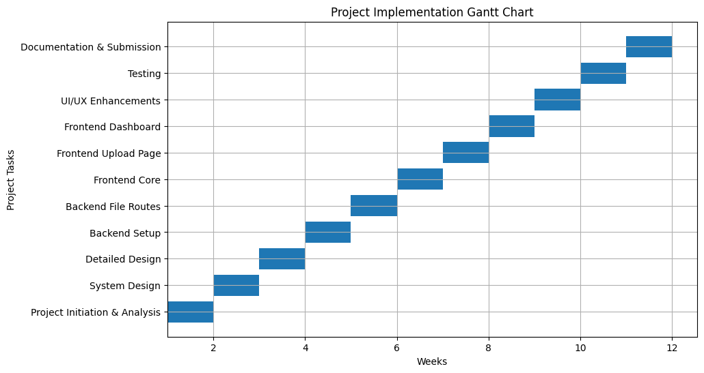

APPENDIX D: PLAGIARISM REPORT
